1. **Proposed Title**

**INDUSTRIAL ACADEMIA COORDINATION SYSTEM**

1. **How would you categorize this project? [Tick only ONE]**
   1. An effort to facilitate an existing Research/ Industry Project
   2. An effort to facilitate developing a Research/ Industry Funded Proposal for possible Funding
   3. An effort to facilitate Master’s/ PhD project objectives
   4. An exploratory study
   5. An experimental study for better lab utilization/ development
   6. A capstone project for students allowing them to apply their learning
   7. Other (please specify):  **An effort to facilitate institution from coordination between industry and undergraduate student**.
2. **What characteristics of the Complex Engineering Problem (CEP) are applicable to this project? [Tick one or more, if applicable]**
   1. Range of conflicting requirements: technical, engineering, or other issues. **🗸**
   2. Depth of analysis required: have no obvious solution and require abstract thinking
   3. Depth of knowledge required: require research-based knowledge
   4. Familiarity of issues: Involve infrequently encountered issues
   5. Extent of applicable codes: standards and codes devised by the professional bodies
   6. Extent of stakeholder involvement and level of conflicting requirements
   7. Consequences: Impact over the society
   8. Interdependence: problems due to dependability
3. **Brief Outline**

The Industrial Academia Corporation system is a tool to bring coordination between undergraduate’s students and their respective industries. It’s a general system we can implement in an industrial zone with respect to their needs. In our project we design for software engineering and information technology domain as we belong to software engineering departments. It registered software houses and students as well. Both have their profile that can be managed by department admin. Software houses posted jobs, internships according to their needs and it would be sent towards the respective students who are willing to do it. If students want a job or internships but they don't have certain skills, so training sessions are also arranged by the department for deserving students. Our major problem is that deserving people can’t get what they want either jobs, internships, scholarships, or financial support. If someone needs a scholarship, laptops or financial support so he can take the available one or can request to admin for his need. Overall, it can solve most of the problems, hurdles faced by students in their academic career.

1. **Objectives**

In our country most people are jobless, and they graduate as well, not because of jobs not available because their field or their desired jobs are not available. All these problems occur because there is a huge gap between universities and industries which creates a lot of problems. Our main objective of this project is to overcome the gap between industries and university students. It can help students to grow their professional career with their respective industries.

1. **Scope**

Our project facilitates students for getting Jobs, Internship, Training, Scholarship and Donation.

* **Jobs/Internship** – In Jobs/internship features, whenever the institute (NED University) gets a request of Jobs or internships from Software house/Organization then an associative person posts the job description to overall students and recommends to desirable students. In other cases, if the organization has registered to our portal, then they are capable of directly posting the Jobs and Internships and also able to see the recurties of institutes.
* **Training** – In our application, Many trainer are registered and provide the service of educate the student (like, provide the training of C#, Java, React, Blockchain, AI and other skills as required by jobs Description and future trends). It helps the students to learn only those skills in which they do the jobs.
* **Funding/Scholarship** – If the Software house/Organization wants to contribute and provides software projects ideas to students then our application provides assistance to industrial people and students to interact with each other, also students get the opportunity to work in real time projects. Our application provides a facility to students to get scholarships easily by the help of registered Sponsor.
* **Donation** **–** In most cases students don't have Resources like laptops to study and other resources for particular Purpose (Like software projects donation) and we have a certain organization that wants to donate resources (Are in Physical state or the Monetary value of resource). So, we provide ease to students to request any type of resource through their dashboard and facilitate donors to easily interact with high level personnel of the institute to give them resources by the help donations buttons.

1. **Stakeholders:**

There are mainly five stakeholders in this project, which are directly or indirectly affected by the system. **Students** can affail jobs, internships, project all respective services that they want, **Industries** are the bodies that provide jobs, internship and assign projects. **University management (DIL)** is responsible to authenticate students, industries and other bodies who can be a part of this system. These are the three main stakeholders which usually interact but there is other two also, **Sponsors** and **Donors** any organization and industry be a part of that two stakeholder. They belong to a non-educational purpose, Sponsors and Donors motive is to provide the financial resource to students.

1. **Methodology**

We use agile methodology. Our project Idea proposed by our teacher Dr. Wahab. It’s his requirement to build a minimal viable product that’s why we use agile methodology. We add incremental builds after a week or according to our feedback. For front end development we use open-source JavaScript library ReactJs. It's the best library for developing interactive user interfaces. For backend we use Node Js and some relational databases. We integrate our project to the university database to get students' data.

1. **Expected Outcomes of the proposed project**

Our main motive to build this system is to overcome the gap between industries and undergraduate students. The Outcome of this project is, students can easily get internships, jobs according to their skills or they can upgrade their skills working their respective industries. Industries can easily get the best employees for their needs; With the help of this project a communication bond can be established between undergraduates and industries.

1. **Expected Budget**

We are not using any paid tools, so our project has no expected budget.

1. **Attach Gantt Chart for the Project Work  
     
   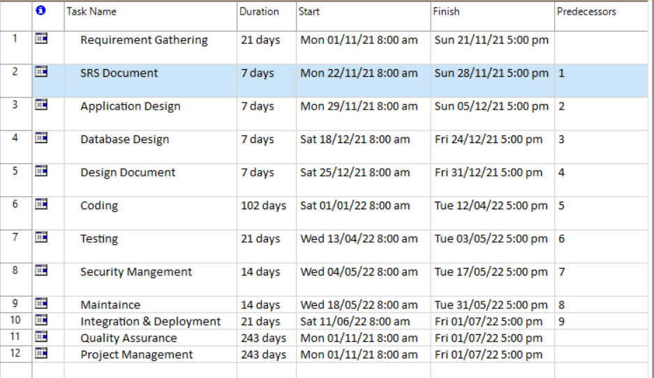  
     
   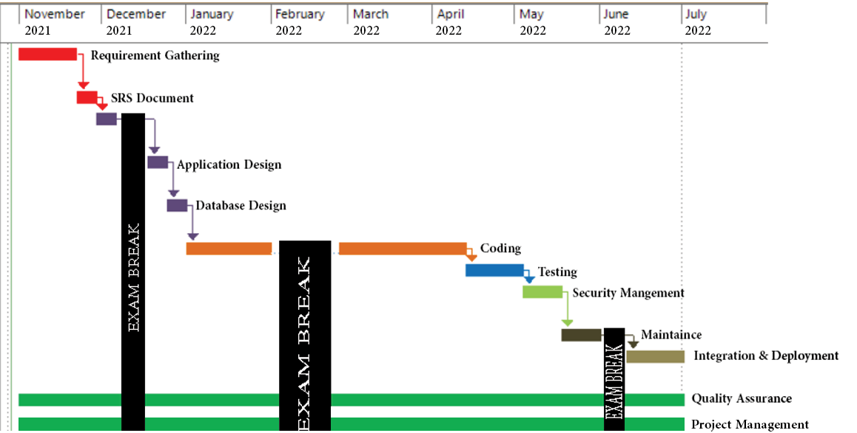**
2. **Alignment of project with departmental/programme mission and SDGs*.***

The responsibility of the software engineer is to provide solutions to social problems, not to automate the system. The motive of the Industrial Academia Corporation system is to overcome the gap between Industry and students. It can help to solve the job problem faced by every undergraduate student after the degree. In our country poverty is very high which can only be solved by jobs and that’s what we are trying to do.

* **Project Alignment with SDGs.**

No Poverty.

Gender Equality.

Name of Supervisor:   
  
  
**Dr. Wahabuddin Usmani**

Name of Co-Supervisor (if any):

Signature:  
  
  
 .

Signature:  
  
  
 .

Name of Industrial Advisor (if any): **Hasnain Tayyab**

**Recommendations and Approval:**

**Chairperson (Head of FYDP Review Committee) Sign with Date:**